Exercise 2: Implementing Dependency Injection

Scenario
In the library management application, the dependency between BookService and BookRepository needs to be managed using Spring's Inversion of Control (IoC) and Dependency Injection (DI), instead of BookService creating its own BookRepository instance directly.

Objective
Update the XML configuration so BookRepository is wired into BookService, confirm that BookService exposes a setter for BookRepository, and run a main class named LibraryManagementApplication to verify the injection works.

Project Setup
This exercise was created as its own Maven module, separate from Exercise 1, so each exercise stays independent and easy to review.
- A new project folder named 'Exercise 2 Implementing Dependency Injection' was created alongside the other exercises.
- A pom.xml file was added to the folder with the spring-context dependency, turning it into a Maven module.
- The standard Maven folders src/main/java and src/main/resources were created.
- The package com.library.repository was created, containing the class BookRepository.
- The package com.library.service was created, containing the class BookService with a setter method for BookRepository.
- applicationContext.xml was added under src/main/resources, defining beans for both classes and wiring BookRepository into BookService via setter injection.
- A main class named LibraryManagementApplication was created inside com.library to load the Spring context and test the wiring.
- The module's SDK was set to Java 17 in Project Structure, since it initially defaulted to an unsupported older JVM target.
- LibraryManagementApplication was run, and the console output was verified.

pom.xml
The Maven configuration file for this module:
<project xmlns="http://maven.apache.org/POM/4.0.0">
<modelVersion>4.0.0</modelVersion>

<groupId>com.library</groupId>
<artifactId>Exercise2-DependencyInjection</artifactId>
<version>1.0</version>

<properties>
<maven.compiler.source>17</maven.compiler.source>
<maven.compiler.target>17</maven.compiler.target>
</properties>

<dependencies>
<dependency>
<groupId>org.springframework</groupId>
<artifactId>spring-context</artifactId>
<version>5.3.30</version>
</dependency>
</dependencies>
</project>

BookRepository.java
This class plays the role of the data source. It returns a book based on its ID:
package com.library.repository;

public class BookRepository {

public String getBookById(int id) {
return "Book with ID " + id + ": The Great Gatsby";
}
}

BookService.java
BookService depends on BookRepository. The setBookRepository method is what allows Spring to inject the repository, rather than BookService creating one itself:
package com.library.service;

import com.library.repository.BookRepository;

public class BookService {

private BookRepository bookRepository;

public void setBookRepository(BookRepository bookRepository) {
this.bookRepository = bookRepository;
}

public String findBook(int id) {
return bookRepository.getBookById(id);
}
}

applicationContext.xml
This is the key configuration for this exercise: it declares both beans and instructs Spring to inject bookRepository into bookService using the setter defined above:
<beans xmlns="http://www.springframework.org/schema/beans"
xmlns:xsi="http://www.w3.org/2001/XMLSchema-instance"
xsi:schemaLocation="http://www.springframework.org/schema/beans
http://www.springframework.org/schema/beans/spring-beans.xsd">

<bean id="bookRepository" class="com.library.repository.BookRepository" />

<bean id="bookService" class="com.library.service.BookService">
<property name="bookRepository" ref="bookRepository" />
</bean>

</beans>

LibraryManagementApplication.java
This class loads the Spring context from applicationContext.xml, retrieves the bookService bean, and calls it to confirm that the dependency injection took effect:
package com.library;

import com.library.service.BookService;
import org.springframework.context.ApplicationContext;
import org.springframework.context.support.ClassPathXmlApplicationContext;

public class LibraryManagementApplication {

public static void main(String[] args) {
ApplicationContext context =
new ClassPathXmlApplicationContext("applicationContext.xml");

BookService bookService = (BookService) context.getBean("bookService");

System.out.println(bookService.findBook(101));
}
}

Running the Application
LibraryManagementApplication was run directly from IntelliJ (right-click inside the file → Run 'LibraryManagementApplication.main()'). The screenshot below shows the finished project structure and the console output produced after running the program.

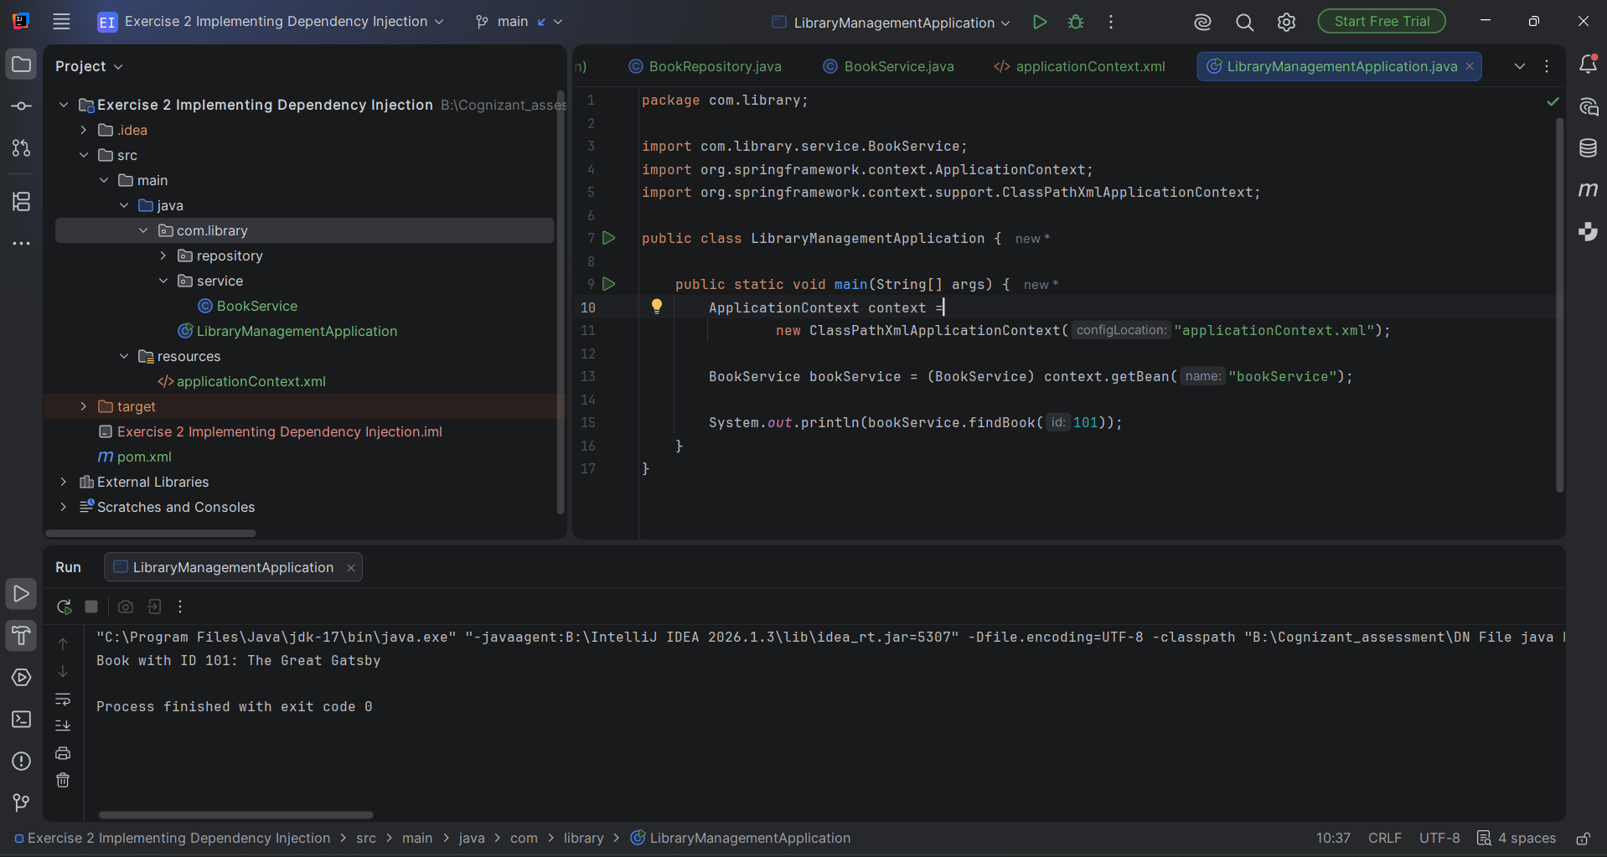
Figure 1: IntelliJ IDEA project view showing LibraryManagementApplication.java and the console output.

Result
Running the program produced the following console output, confirming that Spring created both beans and successfully injected BookRepository into BookService through the setter method:
Book with ID 101: The Great Gatsby

Process finished with exit code 0

Conclusion
This exercise focused specifically on Dependency Injection: rather than BookService constructing its own BookRepository, Spring's IoC container created both objects and wired BookRepository into BookService automatically, based purely on the configuration in applicationContext.xml. The successful console output confirms the injection was set up correctly and that the two classes remain loosely coupled, since BookService never needs to know how BookRepository is created.

